**MARKET CONNECT**

**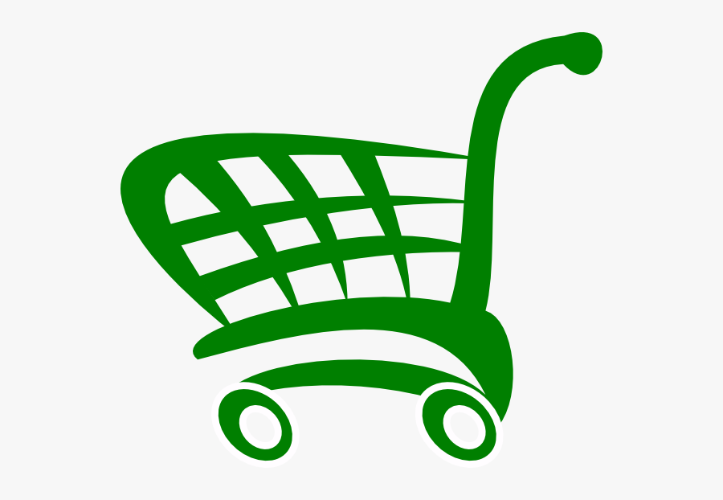**

Login Sign Up



Market Information

|  |
| --- |
| Get in touch with customers - simply a click away.  C:\Users\Nateete\Downloads\MARKET FARM PRODUCE.png  LANDING PAGE:  User clicks to connect to prospective customers and for market information  C:\Users\Nateete\Downloads\16cee4ef16e76df45daecdc0e10acea5--scales-of-justice-tattoo-lawyer-website.jpg  C:\Users\Nateete\Downloads\data-vs-informaton.jpg  C:\Users\Nateete\Downloads\people-circle-connections-social-business-network-16142158.jpg  Check out information on markets  What you need legally to start selling  Connect to customers |
| Search information on available market and marketing tips   * Websites   INFORMATION:  Links to adverts on markets for farm produce and marketing tips for farmers  C:\Users\Nateete\Downloads\data-vs-informaton.jpg   * TV Ads * Newspaper Ads * Radio Infomercials * Legal Information * Connect to other farmers |
| Upload your image of your product/ service  C:\Users\Nateete\Downloads\unnamed.png  FARMER:  Uploads image showcasing the product/ service they offer and a short description of the product/ service  Description |
| Connect to your clients  C:\Users\Nateete\Downloads\195-1951339_payment-computer-icons-money-logo-payment-terms-icon.png  C:\Users\Nateete\Downloads\1e37f76662b506253f3877a91474b7b1.jpg  C:\Users\Nateete\Downloads\png-clipart-computer-icons-location-google-maps-location-icon-black-map-thumbnail.png  Preferred payment methods  C:\Users\Nateete\Downloads\people-circle-connections-social-business-network-16142158.jpg  FARMER:  Enters information on preferred payment methods, delivery options and their location details  Delivery Options  Location details |